Below is a **comprehensive analysis** incorporating the latest charts, tables, and commentary on the S&P 500’s *post‐inaugural* performance, current technical levels, and portfolio updates. The overarching theme is a market sliding deeper into *correction territory* amid heightened economic and policy uncertainty—yet still not entirely following the 2020 script.

**1. Macro Context: Tariffs, Uncertainty, and Comparisons to 2020**

* **Tariff Policy & Uncertainty**: The back-and-forth (“tip for tap”) tariff approach has contributed to rising economic worries, pulling the market lower. Some commentators liken it to the dramatic 2020 sell-off (COVID-19 onset), but conditions are different now:
  + **Monetary Policy** is more constrained (rates are higher, and the Fed is less likely to cut).
  + **Economic Fundamentals** (employment, corporate earnings) are generally stronger than in early 2020.
  + **Global Conditions** are less about a pandemic shutdown and more about policy headwinds and inflationary pressures.

**Bottom Line**: While the retreat *feels* reminiscent of 2020 in terms of speed, it may reverse just as quickly if tariff and policy uncertainties are clarified or de-escalated.

**2. When Might This Correction End? Insights from Post‐Inaugural Data**

**A. Historical Patterns Around Inauguration Day**

**Charts Referenced**

1. *S&P 500 Performance Before & After Inauguration Day Since 1945* (lines for All, Republicans, Democrats, and “Trump 2.0”)
2. *S&P 500 Performance Following Presidential Inauguration Days 1945–Present* (table)

* **Current “Trump 2.0” Trajectory**:
  + The black line (“Trump 2.0”) is tracking the historical Republican line (red) fairly closely but **with greater magnitude** to the downside.
  + Historically, markets under Republican presidencies in *post‐election years* have lagged those under Democrats (as noted in the 2025 Almanac, page 28).
* **Typical Timing for a Bottom**:
  + In past Republican post‐inaugural markets, an *initial* bottom often appears in the **second half of March**, followed by a possible **retest in early April**.
  + After that retest, the market historically began to recover, in line with the fundamental principle that once uncertainty lifts, indices often bounce back.
* **Seven‐Week Checkpoint**:
  + As of **seven weeks** post‐Inauguration Day (March 10 this cycle), the S&P 500 was down about **6.37%**—the **4th worst** post‐inaugural performance since 1945.
  + **Past Patterns**: Even after a weak first 7 weeks, a recovery into the 12‐week and 100‐day marks is not uncommon (per the table, average returns improve the longer one goes out from Inauguration Day).

**Conclusion**: The data suggest we could be nearing a potential first low in late March, with possible retests or further consolidation into early April before a more sustained rebound.

**3. Where Might the S&P 500 Bottom Out? Technical Levels**

**Chart Referenced**

* *S&P 500 Daily Bars with Moving Averages & Support Lines*
* **Recent Breakdown**: The S&P 500 slipped below its **200‐day moving average**, a psychologically and technically important level, and currently sits near **5500** (as of March 13).
* **Key Support Areas**:
  1. **5475 Region**: Trendline support drawn from last April’s lows through the August lows.
  2. **5390 Region**: Near the September 2024 lows. A decline to **5390** would mark about a **12.3%** drop from the all‐time high—close to the **average 14.1%** bull‐market correction since 1948.
  3. **Below 5390**: 5250–5190 could be next potential zones, but that would likely coincide with an even sharper market pullback.

**Conclusion**: If history and technicals rhyme, a **bottom** could form in the **5475–5390** zone in late March or early April, aligning with the typical *Republican* post‐inaugural pattern.

**4. Stock Portfolio Updates**

Over the past four weeks (through March 12):

* **S&P 500**: –7.5%
* **Russell 2000**: –10.2%
* **Almanac Investor Stock Portfolio** (overall): –2.7%

The portfolio’s **cash buffer** (boosted by timely Free Lunch closures) helped mitigate losses. Here’s a closer look at each segment:

**A. Free Lunch Portfolio**

* Fully **closed** on **February 14** at the average daily prices.
* Despite a challenging year for small caps and no strong “January Effect,” a few positions produced double‐digit returns (e.g., Innovex International with +30.1%).

**B. Small‐Cap Portfolio**

1. **Mama’s Creations (MAMA)**
   * Final half‐position was **stopped out** on Feb 24 at $6.23, realizing a **total gain of 86.8%**.
   * MAMA had significant volatility; when combined with broader market weakness, it dipped quickly.
2. **Healwell AI (HWAIF)**
   * Down **30.4%** as of March 12.
   * A “ground‐floor” opportunity in **healthcare + AI** with rising revenues and potential catalysts.
   * **Buy Limit**: $0.99, for those comfortable with small, speculative positions and who believe demand for AI in healthcare will rebound with market stabilization.
3. **Northeast Community Bncp (NECB)**, **Navigator Holdings (NVGS)**, etc.
   * Positions remain in the portfolio, though small caps overall remain under pressure.

**C. Mid‐Cap Portfolio**

* **Skyward Specialty Insurance (SKWD)**:
  + Stopped out on Jan 23 at $42.45 (+38.5%).
  + *Re‐added* on Feb 13, now on **Hold**.
* **Amalgamated Financial (AMAL)**, **Trinity Industries (TRN)**, **IES Holdings (IESC)**:
  + All **stopped out** amid increased volatility, especially those with any AI or cyclical exposure.

**D. Large‐Cap Portfolio**

* **Leonardo DRS (DRS)**, **Sterling Infrastructure (STRL)**, **Comfort Systems (FIX)**:
  + Also **stopped out**. Defense and infrastructure names took hits on possible peace talk speculation and the broader AI/cyclical cooldown.
* **Garmin (GRMN)**:
  + Briefly approached **$250** after strong earnings, but pulled back with the broader market.
  + **Support** is holding above $200. Remains on **Hold**.

**Overall Portfolio Guidance**

* **All unmentioned open positions**: On **Hold** with updated stop losses.
* Use **bouts of market weakness** (especially if S&P 500 nears the 5390–5475 support band) as potential opportunities to *selectively accumulate* long‐term high‐conviction names.

**5. Putting It All Together**

1. **Market Correction & Possible Timing**
   * Historical post‐inaugural performance patterns suggest the *later‐March to early‐April* window as a potential low/retest zone.
   * Growing calls for policy clarity—especially around tariffs—could spark a swift relief rally if uncertainties ease.
2. **Technical Support**
   * Watch **5475** (trendline) and **5390** (September lows) on the S&P 500. A bounce in this range would align with the **average bull‐market correction** of around 14%.
3. **Portfolio Strategy**
   * **High Cash Levels**: The portfolio’s raised cash provided downside protection.
   * **Smaller Speculative Names**: Careful with small caps in high‐volatility environments. HWAIF, for instance, remains an interesting but higher‐risk play.
   * **Selective Buys**: For fundamentally sound mid‐cap and large‐cap positions, consider adding on dips as the market potentially bottoms.
4. **Longer‐Term Outlook**
   * Historically, the market has tended to *recover* in the latter part of a post‐election year, especially after the administration’s initial flurry of policy changes abates.
   * Should the S&P 500 follow the Republican historical pattern, a rebound in Q2–Q3 remains plausible, supporting the **Base Case** for the broader market to end 2025 positively.

**Final Note**

While the current correction has been unsettling—and *faster* than some prior cycles—historical precedents (both technical and post‐inaugural) point to a near‐term bottom forming in **late March or early April**. If support levels hold and uncertainty diminishes, the market could climb out of the correction in a manner similar to previous Republican post‐inaugural years.

In the meantime, **maintain prudent stops**, consider **small‐cap or speculative positions** only if you can tolerate volatility, and look to **add quality names** when the S&P 500 approaches technical and historical support zones.

Here are several **actionable steps** and strategic considerations to keep in mind right now, derived from the discussion:

1. **Monitor the S&P 500’s Key Technical Levels**
   * **5475–5390 Range**: If the market slips further, look for a possible bottom and reversal in this zone. A decisive break below 5390 might signal deeper downside, so adjust stops accordingly.
2. **Anticipate a Late March/Early April Bottom**
   * Historical post‐inaugural data for Republican presidencies suggests the market could find a near‐term low toward the end of March or the start of April, followed by a possible retest. Prepare to **deploy cash** in that window if technicals confirm a supportive bounce.
3. **Use Pullbacks as Buying Opportunities for Core Positions**
   * **Quality Mid‐Caps and Large‐Caps**: If you have been underweight or wish to add to high‐conviction holdings, consider **buying on dips**. The broader market’s correction may offer attractive entry points for fundamentally solid companies.
4. **Exercise Caution with Small Caps & Speculative Names**
   * While volatility remains high, small‐cap stocks, especially those sensitive to AI or high interest rates, can be more vulnerable to sudden sell‐offs.
   * For speculative positions (e.g., **Healwell AI (HWAIF)**), keep a **tight position size** and adhere to a **buy limit** or stop loss to manage risk.
5. **Maintain or Raise Cash Levels (If Needed)**
   * In uncertain markets, holding some cash can help **limit drawdowns** and position you to capitalize on pullbacks quickly.
   * A higher cash buffer helped cushion the portfolio’s recent losses and can continue to serve that purpose if volatility persists.
6. **Adhere to Updated Stop Losses**
   * Protect gains in profitable positions or limit deeper losses in underperformers by using carefully placed stop orders, especially if the market breaches key support levels.
7. **Watch for Policy/News Shifts**
   * Market sentiment could shift rapidly if tariff or policy uncertainties are clarified. Positive developments may trigger a **sharp relief rally**—be prepared with a watchlist of stocks you want to accumulate when conditions improve.

By combining these steps—closely monitoring support levels, strategically deploying cash on dips, managing small-cap risk, and paying attention to policy news—you’ll be better positioned to navigate ongoing volatility while preparing for a possible rebound later this spring.

Below is a **brief overview** of the four images mentioned, based on their descriptions and references in the text:

**1. 30 Trading Days Before & 100 Trading Days After Chart**

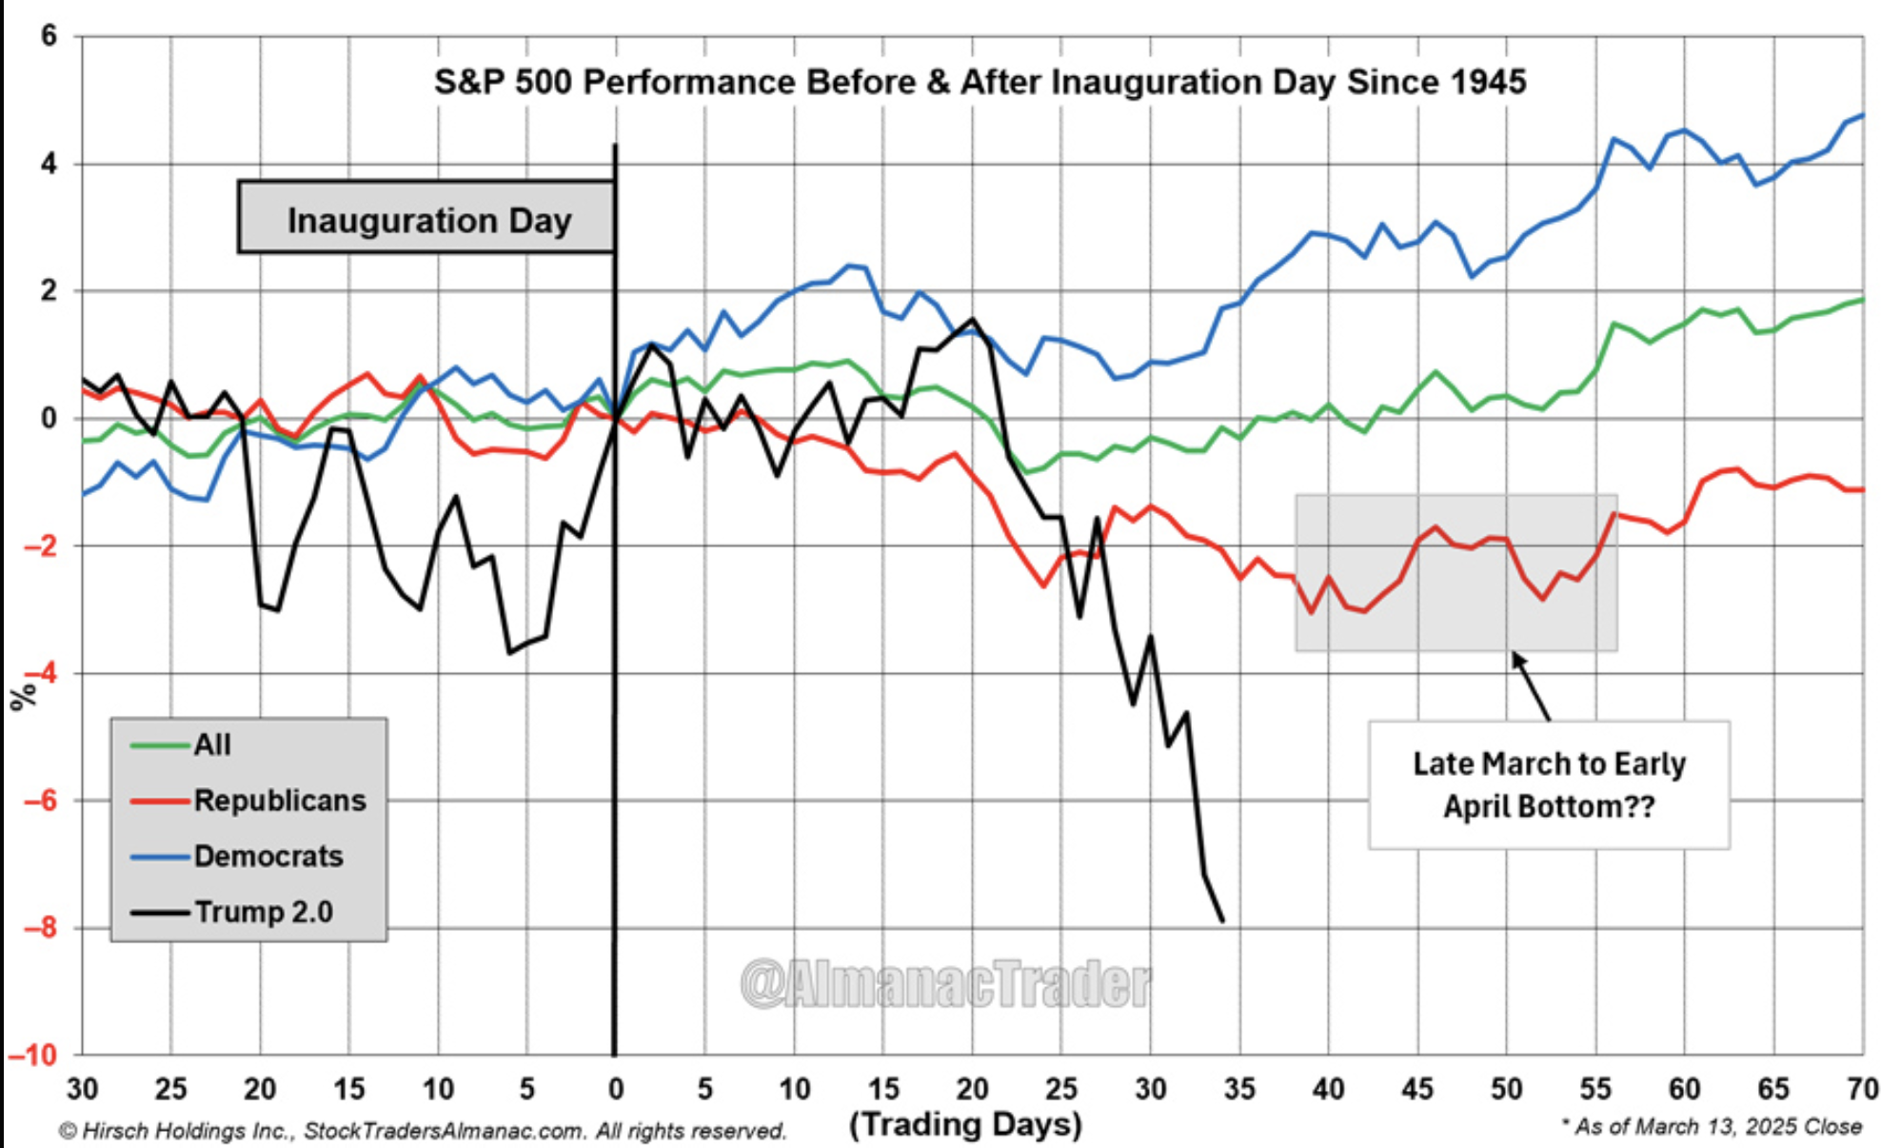

* **What It Shows**:  
  A line chart comparing S&P 500 performance around past presidential inaugurations—30 trading days *before* and 100 trading days *after* Inauguration Day.
* **Lines/Series**:
  + An overall average of all past inaugurations (the “All” line).
  + A separate average for Republican presidents.
  + A separate average for Democratic presidents.
  + A specific line labeled “Trump 2.0,” which represents the **current** S&P 500 performance so far in this post‐inaugural period.
* **Key Takeaway**:
  + The chart sets Inauguration Day to **zero** on the Y‐axis, making it easy to see *how far above or below* the market is relative to the day a new (or returning) president took office.
  + Historically, Republicans show weaker performance in the early post‐inaugural phase than Democrats. “Trump 2.0” appears to be following that Republican pattern, though with a **steeper** drop than average.

**2. S&P 500 Technical Chart**

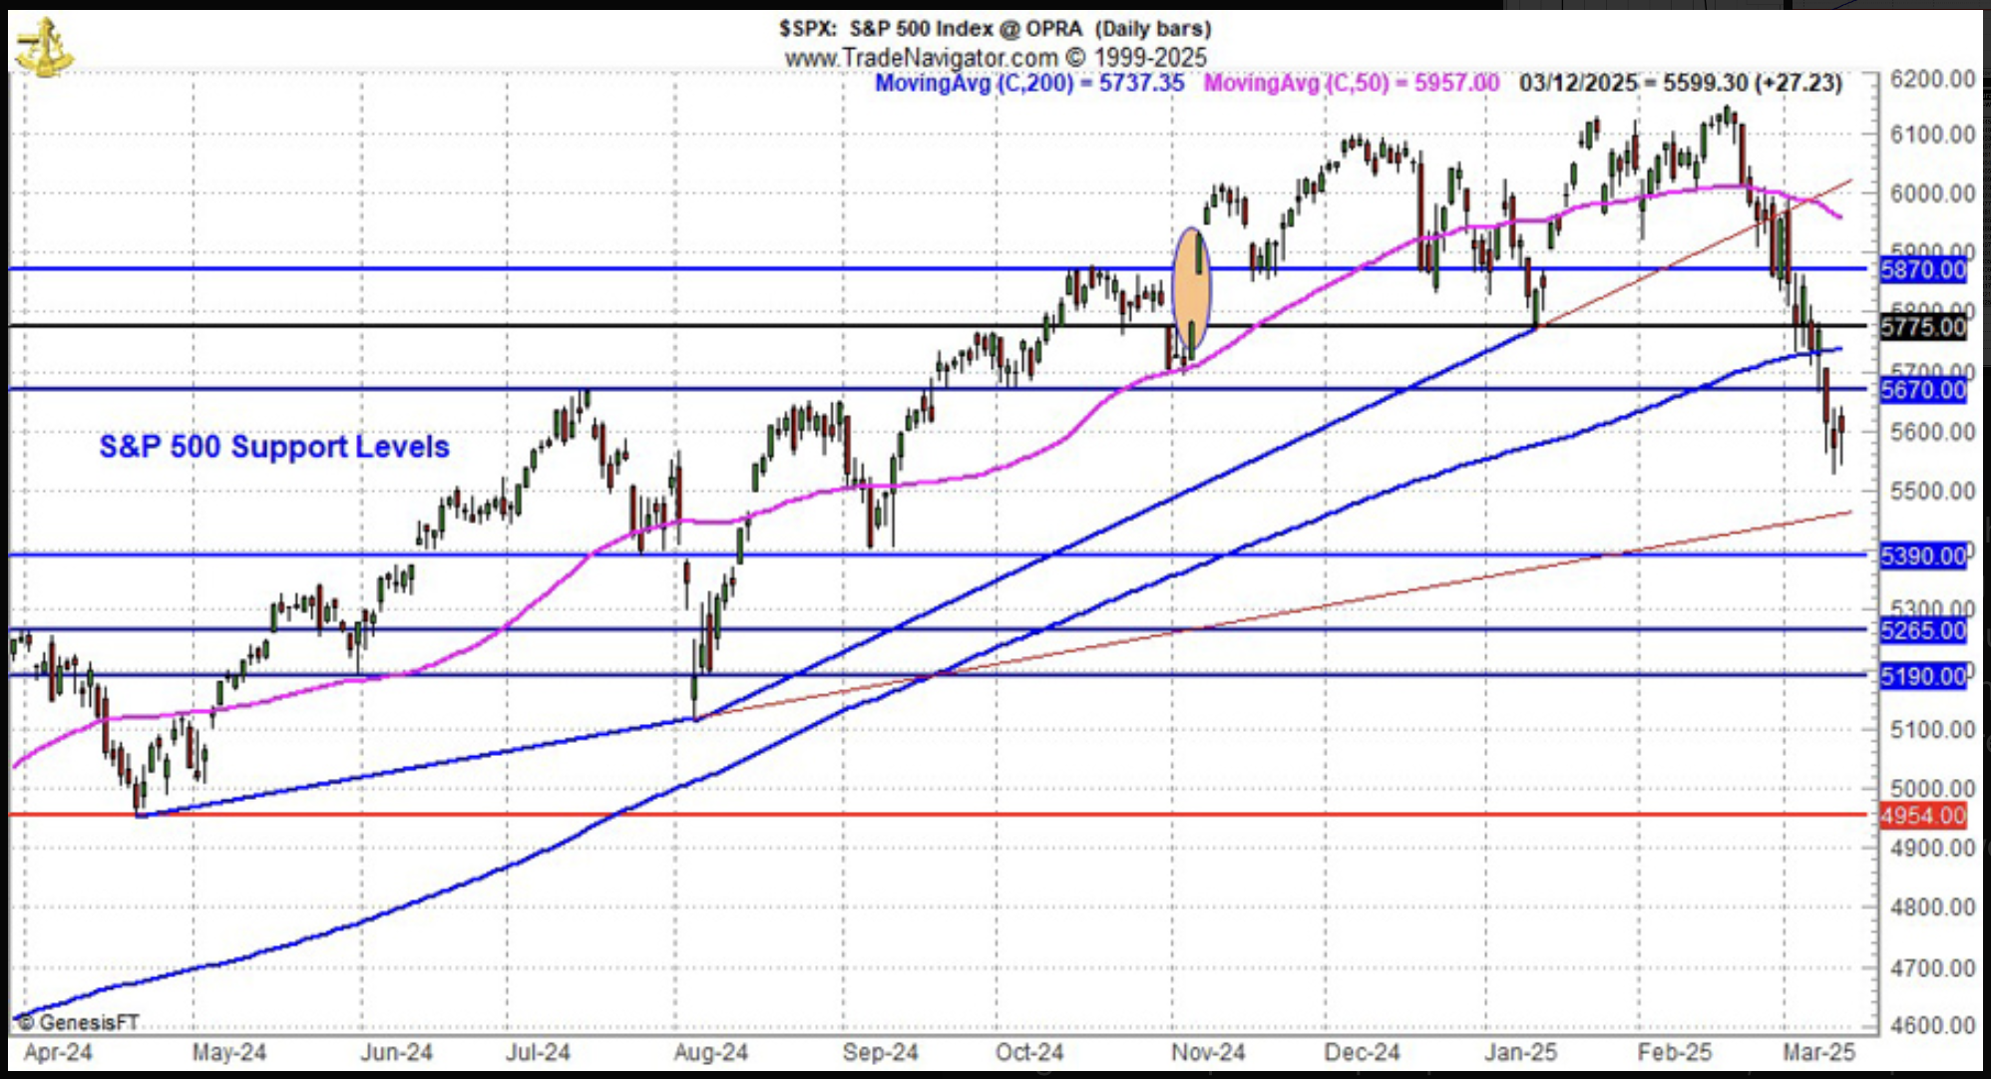

* **What It Shows**:  
  A **daily** chart of the S&P 500 index with significant technical overlays—most notably its **200‐day moving average**—and potential trendlines or support levels.
* **Key Levels/Annotations**:
  + The S&P 500 recently broke below its **200‐day moving average**.
  + The chart highlights support zones around **5475** (a trendline from prior lows) and **5390** (near last September’s lows).
* **Key Takeaway**:
  + The market is “in no man’s land” after breaking important technical support.
  + If the S&P 500 continues lower, the chart suggests the next potential stopping points are **5475** and **5390**.

1. **“4th Worst Post Inaugural S&P 500 Performance since WWII” Table/Blog Excerpt**

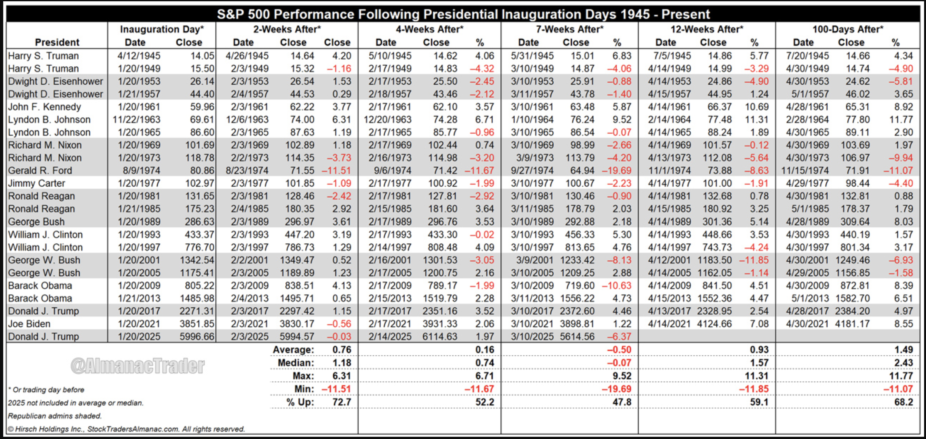

* **What It Shows**:  
  A table of S&P 500 performance following each inauguration since World War II (including mid-term successions such as Truman in 1945 and LBJ in 1963).
* **Data Columns**:
  + S&P 500 performance at **7 weeks**, **12 weeks**, and **100 days** post‐inauguration.
  + Identifies which presidents were Democrats vs. Republicans (Republican rows often shaded in gray).
* **Key Takeaway**:
  + The current (Trump 2.0) 7‐week post‐inaugural performance ranks as the **4th worst** since WWII.
  + Historically, even after a poor start, returns at **12 weeks** and **100 days** have often improved.

**4. Stock Portfolio Updates Table  
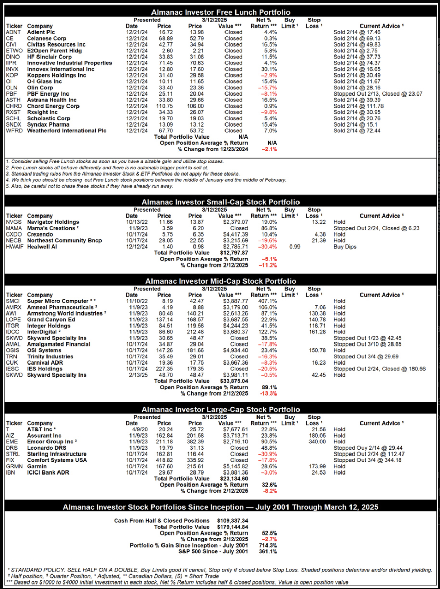**

* **What It Shows**:  
  A summary of open and recently closed positions across **Small‐Cap**, **Mid‐Cap**, and **Large‐Cap** portfolios.
* **Columns Likely Include**:
  + Ticker/Company Name
  + Buy Limit or Entry Price
  + Current Price or Most Recent Price
  + Stop Loss Levels
  + Gains/Losses percentage
  + Notes on whether the position is on *Hold*, *Buy on dips*, or *Closed*.
* **Key Takeaway**:
  + Several positions were stopped out in the recent market downturn.
  + Some positions, like **Garmin (GRMN)**, remain on *Hold* and have support levels to watch.
  + A portion of the portfolio is in **cash**, which helped cushion losses during the broader decline.

By looking at these images together, you get a **holistic view**: the S&P 500 is following a historically weaker Republican post‐inaugural path, has lost short‐term technical support, and the portfolio has been partly shielded by timely exits and cash reserves. The visuals reinforce the message about *where* the market may stabilize (technical supports) and *when* it might begin a recovery (late March/early April, based on post‐inaugural data).